Annay k jis k….jannay k jis k…



Bari mastani…Meri zindagani….

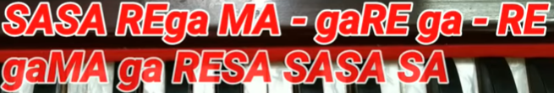

Music:

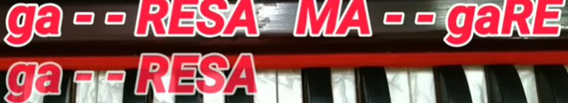



Gunagunaae aise jaise, Bajate ho ghugharu kahi pe



Jharano ki mauj hai wo, Maujo ki ravaani hai meri

